Group meeting memo (May 1st)

* Push latest source files to Github repository
* Add username to navigation bar
* Add login/logout button toggle to front page
* Confirmed new account sign-up is good
* Added login link to front page and templates for login process
* Add logout link after user login is authenticated

<http://127.0.0.1:8000/accounts/login/>

Managers dashboard

http://127.0.0.1:8000/restaurant/dashboard/

Customer dashboard (add more details for each order entry)

http://127.0.0.1:8000/customer/dashboard/

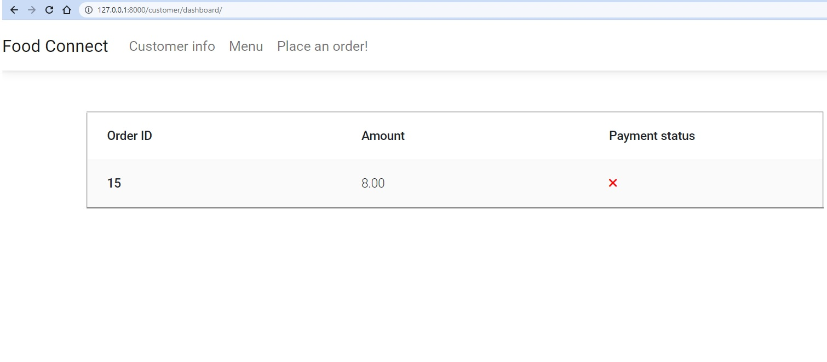

|  |  |
| --- | --- |
| GitHub repository  <https://github.com/mle95/moonshot>  <https://cli.github.com/> |  |

https://winmerge.org/

